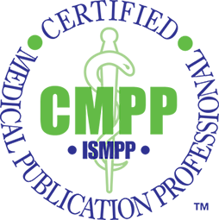
Seeking Task Force Volunteers to Support CMPP Credit Expansion Effort!
The ISMPP Certification (CMPP) Program is looking for 6 to 8 volunteers for a 2-year term to support the expansion of credit-earning opportunities for recertification through proactive identification of qualifying self-study activities.
Self-study is defined as activities in which the instructor and student are separated by time and location, or where the student engages in the learning activity without an instructor. Examples include (but are not limited to): prerecorded audio/video programs, recorded webcasts, self-paced online courses, self-study using printed material, and preparatory courses (online or print).
Potential activities will be submitted for consideration and reviewed by the Recertification Committee to determine whether the activity qualifies for CE credit, the appropriate content domain, and the number of credits.
The Task Force will begin by identifying existing/available activities for consideration and will evolve to recruiting potential faculty to develop content for CMPPs. Participation on this Task Force is open to all ISMPP members (CMPPs and non-CMPPs).
Our goal is to kick-off in September so if you are interested, please email cmpp@ismpp.org by August 1, 2019!
For more information on ISMPP and the CMPP program, please visit www.ismpp.org

